**Problems and Solutions**

Problem 1:

All data is collected in one sheet, which can cause redundancy and reduce performance in the report.

Solution :

I took the data and divided it into sheets: orders, customers, and products. In other words, I applied normalization.

Because it helps prevent redundancy and improves performance.

Problem 2:

In the sheet, Customers and Products are duplicates.

Solution:

Remove duplicates , Because this effect on the insghts such as Number of Customers.

Problem 3:

In the orders sheet, there is a duplicate in the order number, but it is not possible to delete the duplicates because the system records the same order several times depending on the number of items. That is, if the customer takes 3 items, the system records the order three times, each time with a different item.

Solution :

**I created an index column (order id) and that would be the primary key, so I could create a relationship with the rest of the sheets correctly.**

**Problem 4:**

**The names of the columns were not suitable for me, so I changed the names and returned the Data types. There was a problem with the Order Data column, because every time I changed the data to Date, an error appeared.**

**I discovered that time is recorded day month year**

**Solution :**

**I splited the column and then merged it in the appropriate order for Power BI Month Day Year.**

**As for the missing values ​​and outlets, the data did not contain any of them.**

**I have looked at the relevant date columns from the ranking data such as quarter, month, and year. So, it will help me in visuals.**

**Steps in Each sheet:**

**Orders sheet**

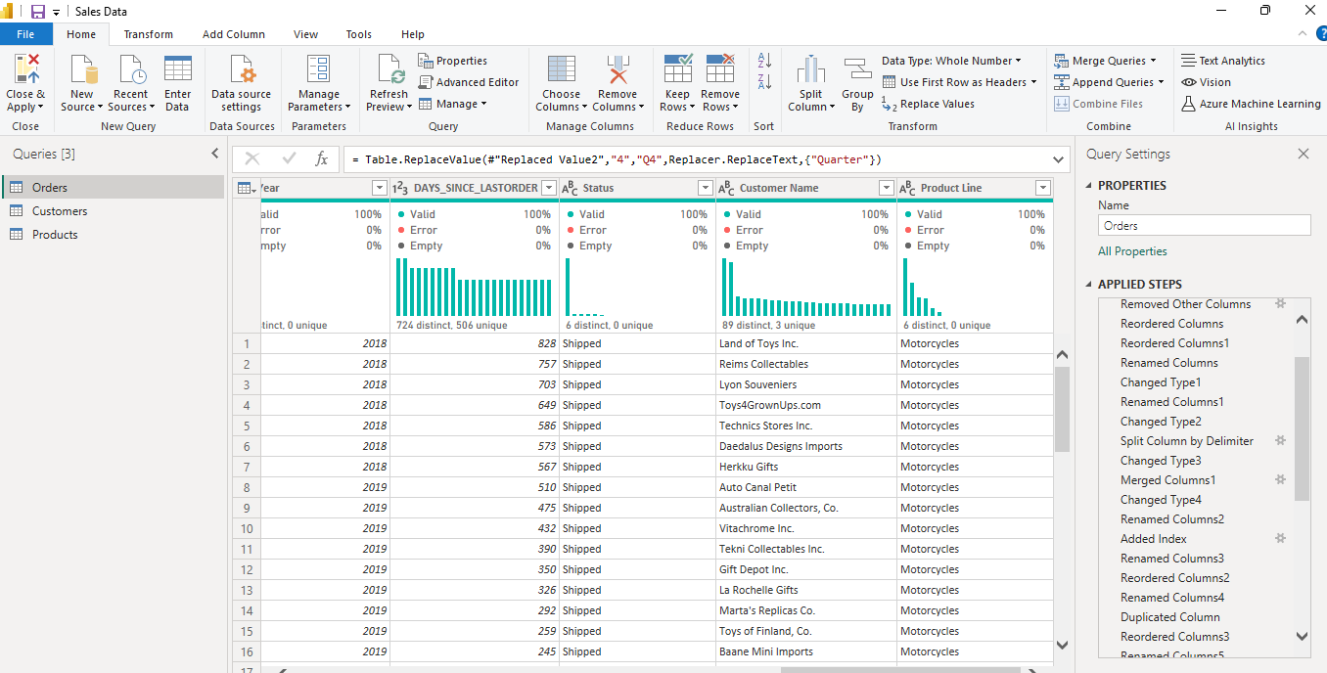

**Customers sheet**

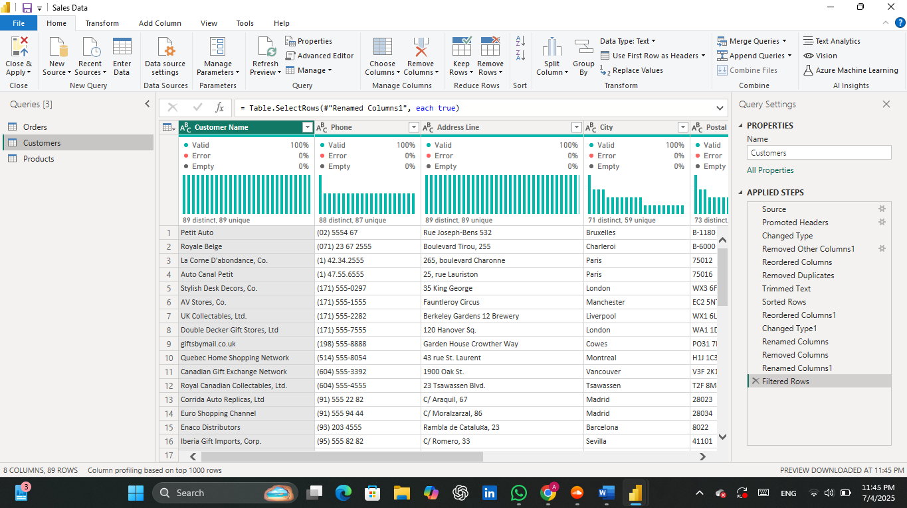

**Products sheet**

